Directory and development Introduce

Introduce File Name：Directory and development Introduce
Introduce File No.：
Version ：V1.0

Total 9 pages
(Including cover)

Compose ZhangYong
Review
Countersign

Cilico Microelectronics Co., Ltd
Modifiy record
File No. | Version | Composed By / Modified By | Compose / Modify Date | Modify Reason | Major changes  （Write main Points） | Review By
 | V1.0 | ZhangYong | 2017.03.27 | None | None | ShiLiangYi
Note: When the file is prepared for the first time, write “None” on "Modify Reason" and "Major modifications columns.

Contents

1. Purpose 4
2. Applicable Scope 4
3. Content 4
3.1 NFC App UseManual 4
3.2 API Introduce 4
3.3 APK 4
3.4 SourceCode 4
4. Development Introduce 4
4.1 Create project 4
4.2 Integrated Tools Class 5
4.3 Configure AndroidManifest 6
4.4 Parse Card Info 7
4.5 CPUUtils Introduce 9

1 Pursose
The introduction of each directory and the secondary development steps.

2 Applicable scope
Adapter for the user who use NFC-enabled PDA.

3 Content
3.1 NFC App UseManual File
The file path is“\nfc_IsoDep_MF3\UserManual\”，Which contains two documents in Chinese and English, by learning this document, you can quickly learn how to use NFC APP to manage MF0 card information.
3.2 API Introduce File
The file path is“\nfc_IsoDep_MF3\APIDocument\”，Which contains two documents in Chinese and English, by learning this document, you can understand how to correct use each method.
3.3 Apk
The file path is“\nfc_IsoDep_MF3\Apk\”。
3.4 SourceCode
The file path is“\nfc_IsoDep_MF3\SourceCode\”。

4 Development introduce
4.1 Create Project
Create a new Android studio project which name isTestNfc.
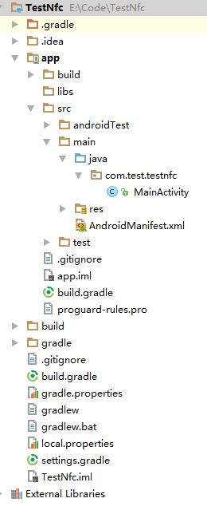
4.2 Integrated Tools Classes
Copy the files below the path to the project.
nfc_IsoDep_MF3\SourceCode\NfcManager\app\src\main\java\com\olc\nfcmanager\CPU
nfc_IsoDep_MF3\SourceCode\NfcManager\app\src\main\java\com\olc\nfcmanager\ParseListener.java
nfc_IsoDep_MF3\SourceCode\NfcManager\app\src\main\java\com\olc\nfcmanager\Utils.java
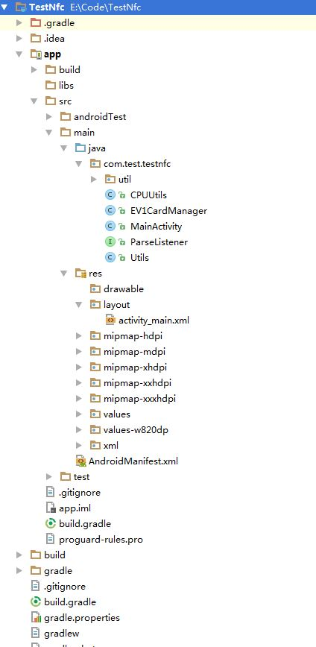
4.3 Configure AndroidManifest
4.3.1 Declare the permissions: android.permission.NFC
4.3.2 Configure Intent-filter、Action and meta-data In MainActivity.java.
4.3.3 Create nfc_tech_filter.xml in res/xml.
4.3.4 Configure launchMode="singleTop" of MainActivity.java
AndroidManifest.xml ：
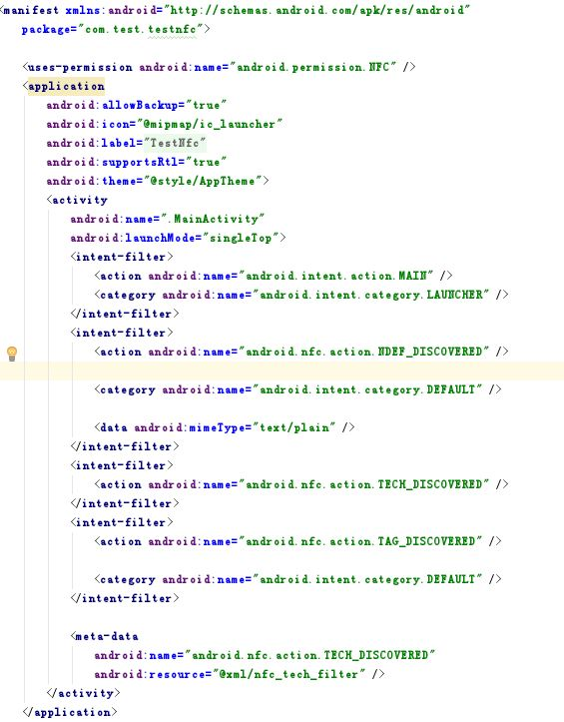
nfc_tech_filter.xml ：
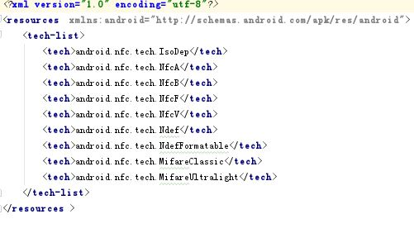
4.4 Parse Card Info
4.4.1 Initialize NfcAcdapter in onCreate and onResume of the MainCctivity.java 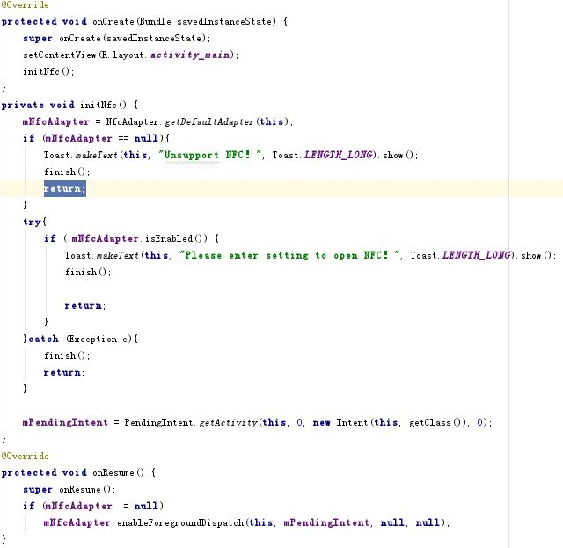
4.4.2 Overrides onNewIntent method of MainActivity.java , get Tag and call CPUUtils class parsing card information, and display it in the interface 。
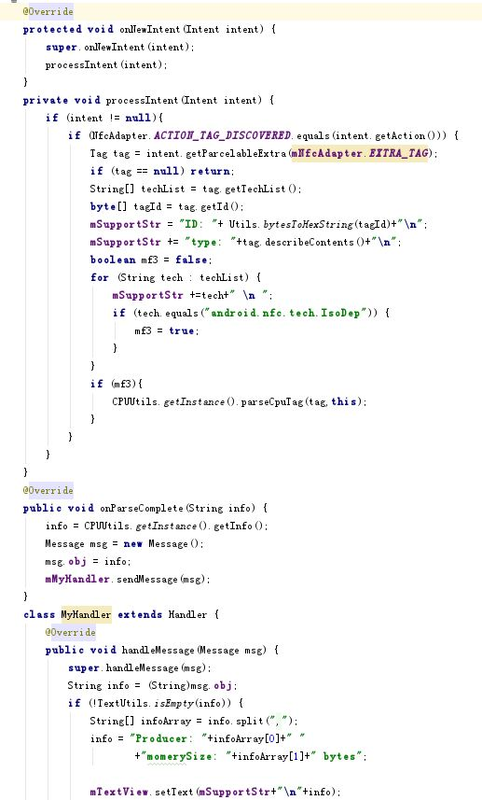
4.5 CPUUtils Introduce
The CPUUtils class contains more ways to operate the card, review the following file：
\nfc_IsoDep_MF3\APIDocument\Introduction of Manage API of MF3.doc

